**What is an Ultrasonic Sensor?**

An Ultrasonic sensor is a device that can measure the distance to an object by using sound waves. It measures distance by sending out a sound wave at a specific frequency and listening for that sound wave to bounce back. By recording the elapsed time between the sound wave being generated and the sound wave bouncing back, it is possible to calculate the distance between the sonar sensor and the object.

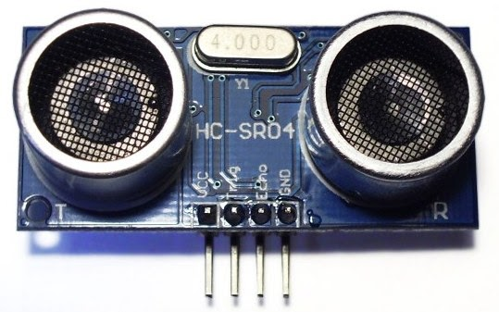

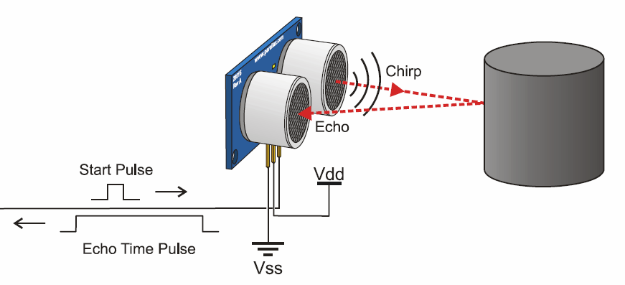

*Diagram of the basic ultrasonic sensor operation*

**Description:** This is the **HC-SR04** ultrasonic ranging sensor. This economical sensor provides 2cm to 400cm of non-contact measurement functionality with a ranging accuracy that can reach up to 3mm. Each HC-SR04 module includes an ultrasonic transmitter, a receiver and a control circuit.

There are only four pins that you need to worry about on the HC-SR04: VCC (Power), Trig (Trigger), Echo (Receive), and GND (Ground).

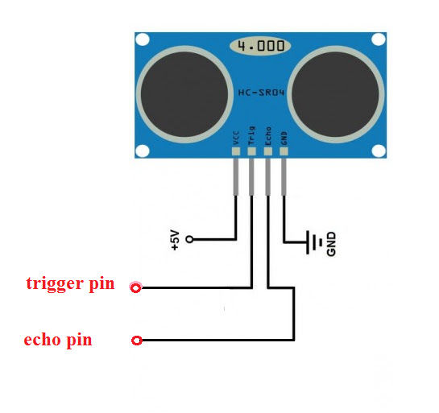

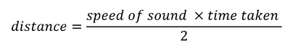Since it is known that sound travels through air at about 344 m/s (1129 ft/s), you can take the time for the sound wave to return and multiply it by 344 meters (or 1129 feet) to find the total round-trip distance of the sound wave. Round-trip means that the sound wave traveled 2 times the distance to the object before it was detected by the sensor; it includes the 'trip' from the sonar sensor to the object AND the 'trip' from the object to the Ultrasonic sensor (after the sound wave bounced off the object). To find the distance to the object, simply divide the round-trip distance in half.

**NOTE:** The accuracy of Ultrasonic sensor can be affected by the temperature and humidity of the air it is being used in. However, for these tutorials and almost any project you will be using these sensors in, this change in accuracy will be negligible.

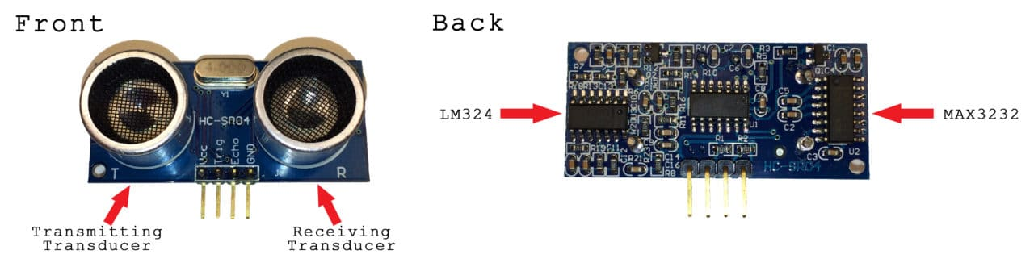

It is important to understand that some objects might not be detected by ultrasonic sensors. This is because some objects are shaped or positioned in such a way that the sound wave bounces off the object, but are deflected away from the Ultrasonic sensor. It is also possible for the object to be too small to reflect enough of the sound wave back to the sensor to be detected. Other objects can absorb the sound wave all together (cloth, carpeting, etc), which means that there is no way for the sensor to detect them accurately. These are important factors to consider when designing and programming a robot using an ultrasonic sensor.

**Why/When to use Ultrasonic Sensors ?**

1. Ideally suited to accurate, automatic distance measurement in normal and difficult environments
2. Particularly suitable for environments where optical sensors are unusable such as smoke, dust and similar.
3. Very accurate, stable and can be used over large ranges.

Ultrasonic sensors can measure the following parameters without contacting the medium to be measured:

* Distance
* Level
* Diameter
* Presence
* Position

Ultrasonic sensors make accurate measurements in many difficult environments and unusual materials. Measurements are unaffected by:

* Material
* Surface
* Light
* Dust
* Mist and Vapor